# Apply filters to SQL queries

## Project description

This project is initiated to proactively identify and address potential security issues related to employee login attempts within a large organization. As a security professional, the primary objective is to thoroughly examine data from the organization's employees and log-in attempts tables, using SQL queries to filter and analyze records. The project aims to detect anomalies, unauthorized access, or any irregularities that may pose security risks. The findings will be documented, and recommendations for mitigation strategies will be provided to enhance the overall security posture.

## Retrieve after hours failed login attempts

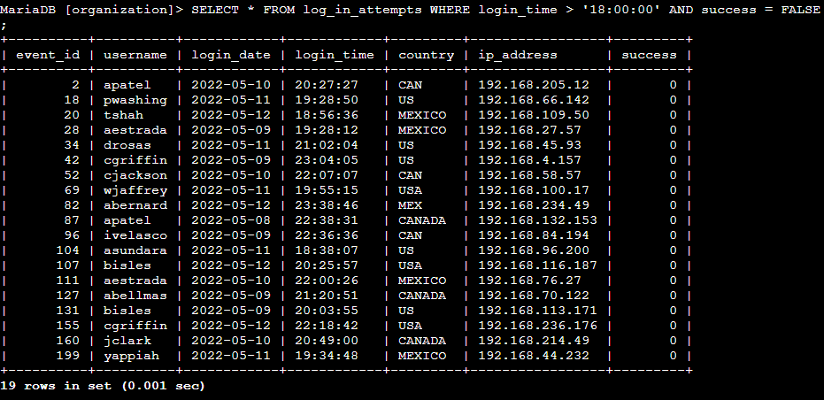

Our SQL query is designed to retrieve records from the log_in_attempts table where the country does not start with 'MEX' and the login attempt was not successful.

## Retrieve login attempts on specific dates

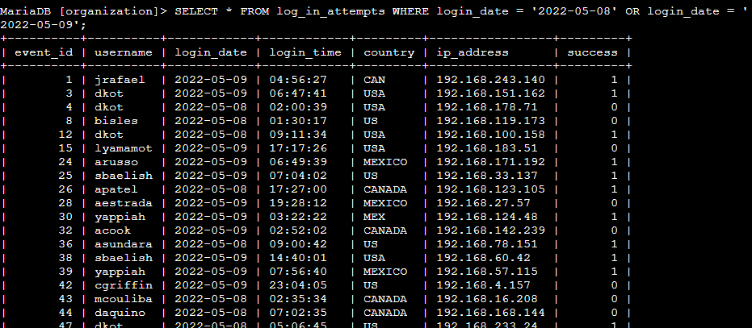

This query is designed to retrieve all columns (*) from the log_in_attempts table where the value in the 'login_date' column is between two particular dates as shown in the screenshot.

## Retrieve login attempts outside of Mexico

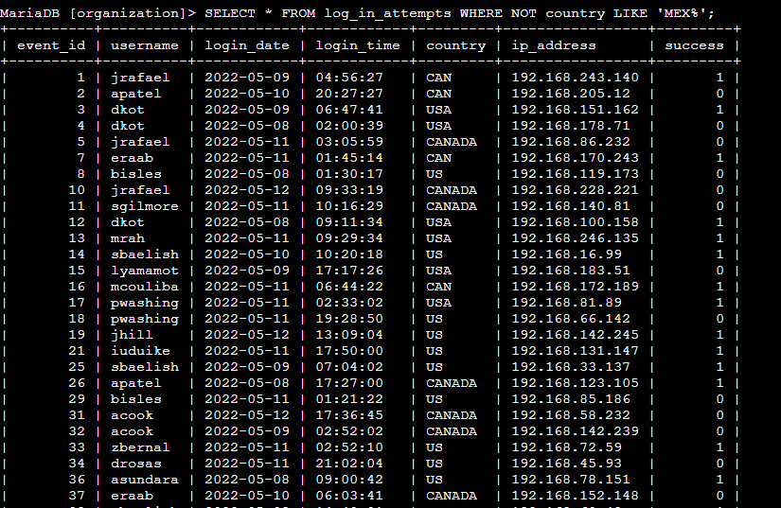

This query is designed to extract data from the log_in_attempts table based on specific criteria related to the 'country' column. WHERE NOT country LIKE 'MEX%': Apply a condition to filter the results. The NOT keyword negates the condition, and country LIKE 'MEX%' checks if the 'country' column starts with 'MEX'. Therefore, the query retrieves records where the 'country' does not start with 'MEX’.

## Retrieve employees in Marketing

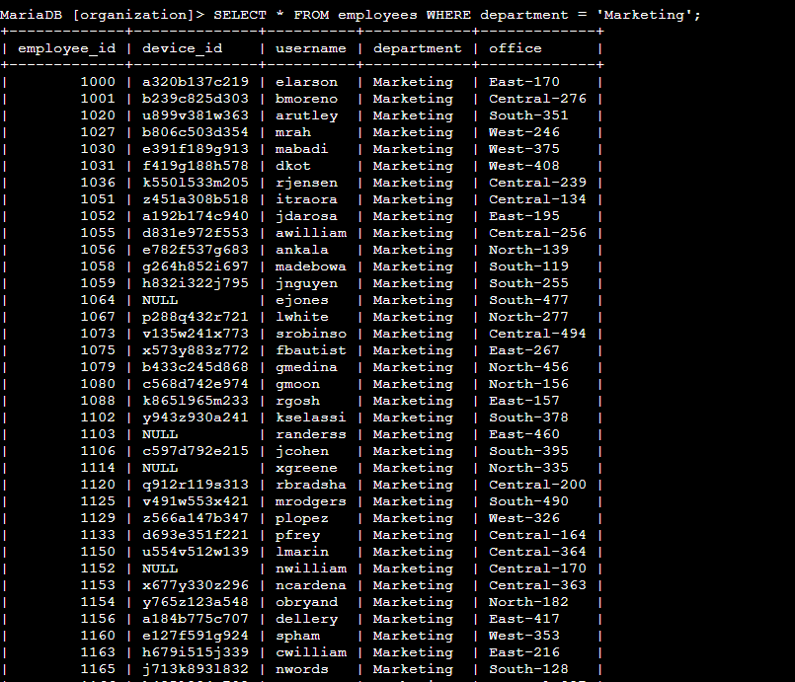

This query is designed to retrieve all columns (*) from the employees table where the value in the 'department' column is 'Marketing'.

## Retrieve employees in Finance or Sales

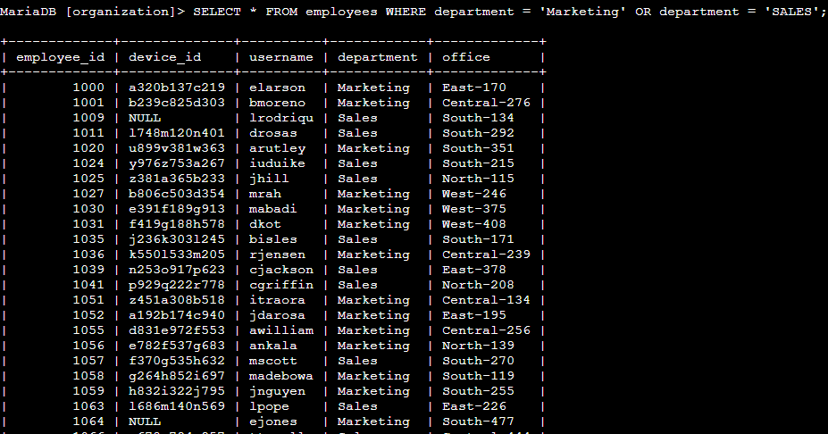

This query is designed to retrieve all columns (*) from the employees table where the value in the 'department' column is 'Marketing' or ‘Sales’.

## Retrieve all employees not in IT

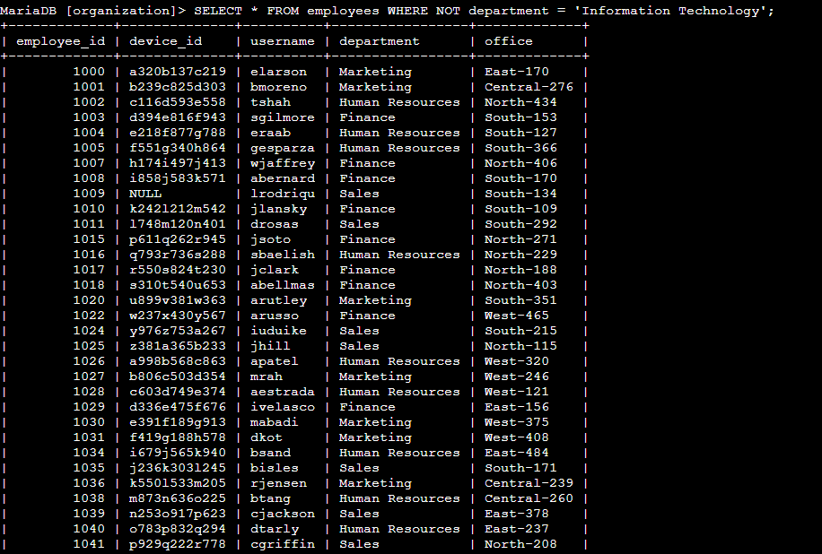

This query is designed to retrieve all columns (*) from the employees table where the value in the 'department' column is NOT 'Information Technology'. We can also use the ‘<>’ operator.

## Summary

I utilized filters in SQL queries to extract specific details regarding login attempts and employee machines. This involved working with two distinct tables, namely 'log_in_attempts' and 'employees.' To refine the results according to the requirements of each task, I employed operators such as AND, OR, and NOT. Additionally, I utilized the LIKE operator in combination with the percentage sign (%) wildcard to filter for specific patterns in the data.